**Supplementary Material**

Thanks to the suggestion of the Editor and Reviewers, we put some of the Figures and Tables into this supplementary material.

1. **Figures**

Every agent makes decisions based on local observations, including the state vectors of *L* jobs. Each vector contains 14 features that describe the state of the current manufacturing environment which is shown in Figure 1.



Figure 1. States for one agent

The proposed multi-agent training framework is shown in Figure 2.



Figure 2. Multi-agent training framework



Figure 3. APN structure

The Pareto fronts shown in Figures 4 and 5 present the Pareto approximations obtained by the different algorithms on two randomly selected instances.

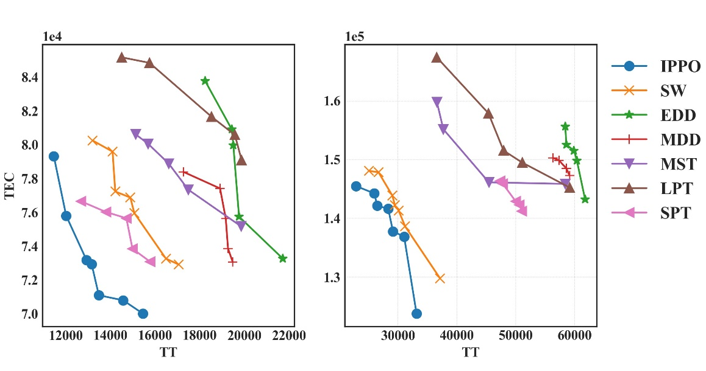

(a) and (b).

Figure 4. Pareto fronts of IPPO and compared rules

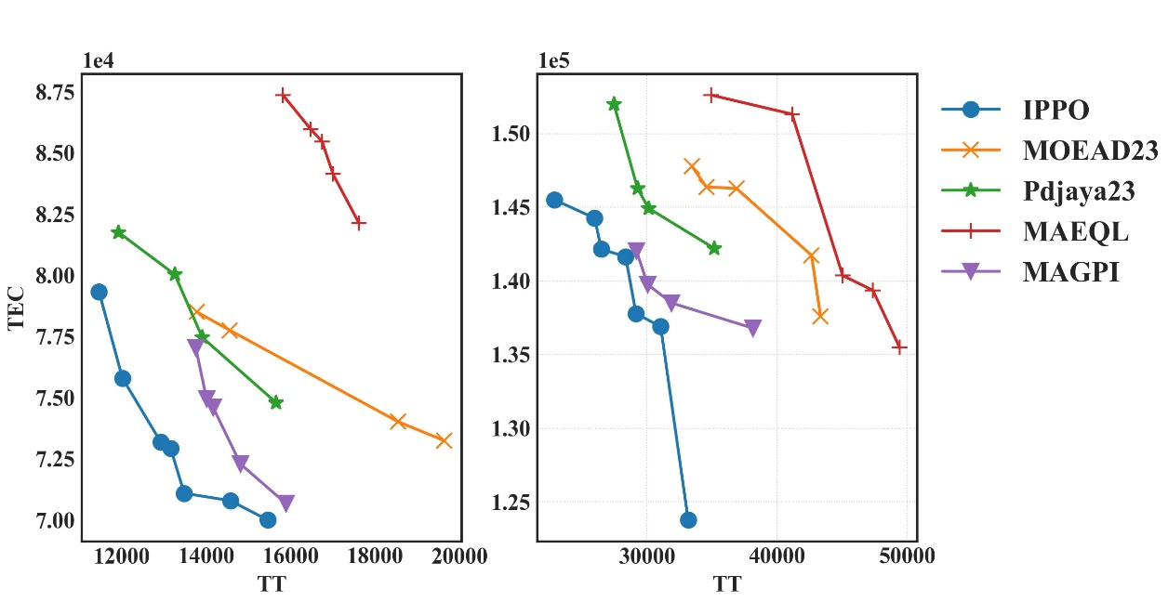

(a) and (b).

Figure 5. Pareto fronts of IPPO and compared algorithms

1. **Tables**

Response values and rank of each parameter in parameter tuning are shown in Table 1.

Table 1. Response value and rank of each parameter

|  |  |  |  |  |
| --- | --- | --- | --- | --- |
| level | B | γ | PR | TR |
| 1 | 2004.772 | 1037.677 | 2146.401 | 484.269 |
| 2 | 646.074 | 904.923 | 1258.204 | 979.019 |
| 3 | 484.268 | 484.267 | 1031.888 | 1173.208 |
| Dalta | 1180.985 | 408.589 | 833.117 | 502.370 |
| rank | 1 | 4 | 2 | 3 |

IGDs and P values of each instance for IPPO, PPO_S, PPO_OL and PPO_U with two different DDT can be found in Table 2, Table 3 and Table 4.

Table 2. IGD values and P values between IPPO and the PPO_S

|  |  |  |  |  |  |  |  |  |
| --- | --- | --- | --- | --- | --- | --- | --- | --- |
| Instances | DDT = 1.0 | | | | DDT = 1.5 | | | |
| IGD | | P | | IGD | | P | |
| PPO_S | IPPO | PPO_S | IPPO | PPO_S | IPPO | PPO_S | IPPO |
| J10E1 | 7.29E+03 | **4.54E+01** | 0.00 | **0.67** | 3.77E+03 | **0.00E+00** | 0.00 | **0.91** |
| J10E2 | 5.44E+03 | **1.60E+03** | 0.00 | **0.50** | 7.56E+03 | **0.00E+00** | 0.00 | **0.88** |
| J10E3 | 4.02E+03 | **3.11E+02** | 0.00 | **0.50** | 6.19E+03 | **1.66E+02** | 0.00 | **0.50** |
| J10E4 | 7.41E+03 | **3.38E+02** | 0.00 | **0.50** | 5.78E+03 | **1.50E+02** | 0.00 | **0.60** |
| J10E5 | 3.87E+03 | **4.90E+02** | 0.00 | **0.40** | 4.22E+03 | **1.78E+02** | 0.00 | **0.50** |
| J20E1 | 9.29E+03 | **0.00E+00** | 0.00 | **1.00** | 9.66E+03 | **6.33E+02** | 0.00 | **0.67** |
| J20E2 | 8.11E+03 | **3.78E+02** | 0.00 | **0.50** | 3.78E+03 | **4.83E+02** | 0.00 | **0.75** |
| J20E3 | 6.68E+03 | **0.00E+00** | 0.00 | **1.00** | 3.16E+03 | **0.00E+00** | 0.00 | **1.00** |
| J20E4 | 5.83E+03 | **3.98E+02** | 0.00 | **0.67** | 5.96E+03 | **0.00E+00** | 0.00 | **1.00** |
| J20E5 | 4.94E+03 | **7.45E+02** | 0.00 | **0.60** | 4.82E+03 | **1.22E+03** | 0.00 | **0.17** |
| J50E1 | 2.18E+03 | **8.07E+02** | 0.00 | **0.50** | 8.23E+03 | **9.08E+02** | 0.00 | **0.50** |
| J50E2 | 4.43E+03 | **9.16E+02** | 0.00 | **0.50** | 6.54E+03 | **0.00E+00** | 0.00 | **1.00** |
| J50E3 | 4.33E+03 | **4.63E+02** | 0.14 | **0.57** | 9.04E+03 | **0.00E+00** | 0.00 | **1.00** |
| J50E4 | 6.84E+03 | **2.11E+02** | 0.00 | **0.75** | 1.22E+04 | **6.87E+02** | 0.00 | **0.67** |
| J50E5 | 4.11E+03 | **1.56E+03** | 0.00 | **0.33** | 8.88E+03 | **0.00E+00** | 0.00 | **1.00** |
| J100E1 | 2.69E+03 | 3.07E+03 | 0.33 | 0.33 | 1.23E+04 | **7.35E+03** | 0.00 | **0.25** |
| J100E2 | 5.86E+03 | **2.14E+03** | 0.00 | **0.33** | 1.93E+04 | **0.00E+00** | 0.00 | **1.00** |
| J100E3 | 8.97E+03 | **1.11E+03** | 0.20 | **0.60** | 1.09E+04 | **0.00E+00** | 0.00 | **1.00** |
| J100E4 | 5.00E+03 | **4.54E+03** | 0.10 | **0.20** | 7.75E+03 | **3.21E+03** | 0.00 | **0.67** |
| J100E5 | 2.30E+03 | **3.40E+03** | 0.50 | **0.33** | 1.41E+04 | **2.78E+03** | 0.00 | **0.70** |
| J200E1 | 2.40E+04 | **8.64E+03** | 0.20 | **0.50** | 7.22E+04 | **3.56E+03** | 0.00 | **0.67** |
| J200E2 | 1.66E+04 | **1.56E+04** | 0.33 | **0.42** | 4.43E+04 | **4.56E+03** | 0.00 | **0.83** |
| J200E3 | 3.25E+04 | **1.86E+04** | 0.20 | **0.60** | 5.80E+04 | **4.85E+03** | 0.00 | **0.75** |
| J200E4 | 2.15E+04 | **1.34E+04** | 0.19 | **0.54** | 1.07E+04 | **2.60E+03** | 0.25 | **0.75** |
| J200E5 | 1.47E+04 | **1.23E+04** | 0.00 | **0.83** | 2.96E+05 | **3.28E+03** | 0.00 | **0.71** |

Table 3. IGD values and P values between IPPO and the PPO_OL

|  |  |  |  |  |  |  |  |  |
| --- | --- | --- | --- | --- | --- | --- | --- | --- |
| Instances | DDT = 1.0 | | | | DDT = 1.5 | | | |
| IGD | | P value | | IGD | | P value | |
| PPO_OL | IPPO | PPO_OL | IPPO | PPO_OL | IPPO | PPO_OL | IPPO |
| J10E1 | 4.50E+02 | **4.54E+01** | 0.33 | **0.67** | 1.02E+03 | **0.00E+00** | 0.09 | **0.91** |
| J10E2 | 1.66E+03 | **1.60E+03** | 0.50 | 0.50 | 3.69E+03 | **0.00E+00** | 0.00 | **0.88** |
| J10E3 | 7.03E+02 | **3.11E+02** | 0.20 | **0.50** | 1.23E+03 | **1.66E+02** | 0.10 | **0.50** |
| J10E4 | 2.06E+02 | **3.38E+02** | 0.25 | **0.50** | 4.78E+03 | **1.50E+02** | 0.00 | **0.60** |
| J10E5 | 4.52E+02 | **4.90E+02** | 0.20 | **0.40** | 1.32E+03 | **1.78E+02** | 0.20 | **0.50** |
| J20E1 | 2.85E+03 | **0.00E+00** | 0.00 | **1.00** | 3.87E+03 | **6.33E+02** | 0.11 | **0.67** |
| J20E2 | 3.20E+02 | **3.78E+02** | 0.30 | **0.50** | 2.44E+03 | **4.83E+02** | 0.00 | **0.75** |
| J20E3 | 1.64E+03 | **0.00E+00** | 0.00 | **1.00** | 1.38E+03 | **0.00E+00** | 0.00 | **1.00** |
| J20E4 | 1.10E+03 | **3.98E+02** | 0.00 | **0.67** | 3.19E+03 | **0.00E+00** | 0.00 | **1.00** |
| J20E5 | 4.11E+03 | **7.45E+02** | 0.00 | **0.60** | 5.51E+02 | 1.22E+03 | 0.67 | 0.17 |
| J50E1 | 1.77E+03 | **8.07E+02** | 0.17 | **0.50** | 1.07E+03 | **9.08E+02** | 0.50 | **0.50** |
| J50E2 | 1.72E+03 | **9.16E+02** | 0.25 | **0.50** | 2.33E+03 | **0.00E+00** | 0.00 | **1.00** |
| J50E3 | 1.55E+03 | **4.63E+02** | 0.29 | **0.57** | 6.65E+03 | **0.00E+00** | 0.00 | **1.00** |
| J50E4 | 2.10E+03 | **2.11E+02** | 0.25 | **0.75** | 2.08E+03 | **6.87E+02** | 0.00 | **0.67** |
| J50E5 | 2.30E+03 | **1.56E+03** | 0.33 | **0.33** | 3.37E+03 | **0.00E+00** | 0.00 | **1.00** |
| J100E1 | 3.61E+03 | **3.07E+03** | 0.17 | **0.33** | 2.83E+02 | 7.35E+03 | 0.75 | 0.25 |
| J100E2 | 2.48E+03 | **2.14E+03** | 0.33 | **0.33** | 1.05E+04 | **0.00E+00** | 0.00 | **1.00** |
| J100E3 | 5.39E+03 | **1.11E+03** | 0.20 | **0.60** | 9.77E+03 | **0.00E+00** | 0.00 | **1.00** |
| J100E4 | 9.60E+03 | **4.54E+03** | 0.00 | **0.20** | 8.07E+03 | **3.21E+03** | 0.00 | **0.67** |
| J100E5 | 5.20E+03 | **3.40E+03** | 0.17 | **0.33** | 7.11E+03 | **2.78E+03** | 0.00 | **0.70** |
| J200E1 | 2.50E+04 | **8.64E+03** | 0.30 | **0.50** | 8.11E+03 | **3.56E+03** | 0.33 | **0.67** |
| J200E2 | 1.78E+04 | **1.56E+04** | 0.25 | **0.42** | 3.33E+04 | **4.56E+03** | 0.00 | **0.83** |
| J200E3 | 5.00E+04 | **1.86E+04** | 0.00 | **0.60** | 1.12E+04 | **4.85E+03** | 0.25 | **0.75** |
| J200E4 | 2.67E+04 | **1.34E+04** | 0.19 | **0.54** | 1.27E+04 | **2.60E+03** | 0.00 | **0.75** |
| J200E5 | 1.60E+04 | **1.23E+04** | 0.17 | **0.83** | 2.19E+04 | **3.28E+03** | 0.14 | **0.71** |

Table 4. IGD values and P values between IPPO and the PPO_U

|  |  |  |  |  |  |  |  |  |
| --- | --- | --- | --- | --- | --- | --- | --- | --- |
| Instances | DDT = 1.0 | | | | DDT = 1.5 | | | |
| IGD | | P | | IGD | | P | |
| PPO_U | IPPO | PPO_U | IPPO | PPO_U | IPPO | PPO_U | IPPO |
| J10E1 | 2.58E+03 | **4.54E+01** | 0.00 | **0.67** | 6.01E+03 | **0.00E+00** | 0.00 | **0.91** |
| J10E2 | 2.12E+03 | **1.60E+03** | 0.00 | **0.50** | 1.29E+03 | **0.00E+00** | 0.13 | **0.88** |
| J10E3 | 5.58E+02 | **3.11E+02** | 0.30 | **0.50** | 3.98E+02 | **1.66E+02** | 0.40 | **0.50** |
| J10E4 | 6.66E+02 | **3.38E+02** | 0.25 | **0.50** | 4.62E+02 | **1.50E+02** | 0.40 | **0.60** |
| J10E5 | 6.64E+02 | **4.90E+02** | 0.40 | **0.40** | 4.31E+02 | **1.78E+02** | 0.30 | **0.50** |
| J20E1 | 1.57E+03 | **0.00E+00** | 0.00 | **1.00** | 6.73E+02 | **6.33E+02** | 0.22 | **0.67** |
| J20E2 | 1.11E+03 | **3.78E+02** | 0.20 | **0.50** | 2.13E+03 | **4.83E+02** | 0.25 | **0.75** |
| J20E3 | 3.85E+03 | **0.00E+00** | 0.00 | **1.00** | 2.77E+03 | **0.00E+00** | 0.00 | **1.00** |
| J20E4 | 1.05E+03 | **3.98E+02** | 0.33 | **0.67** | 1.62E+03 | **0.00E+00** | 0.00 | **1.00** |
| J20E5 | 2.74E+03 | **7.45E+02** | 0.40 | **0.60** | 6.64E+02 | 1.22E+03 | 0.17 | 0.17 |
| J50E1 | 1.52E+03 | **8.07E+02** | 0.33 | **0.50** | 4.09E+03 | **9.08E+02** | 0.00 | **0.50** |
| J50E2 | 1.56E+03 | **9.16E+02** | 0.25 | **0.50** | 4.38E+03 | **0.00E+00** | 0.00 | **1.00** |
| J50E3 | 3.09E+03 | **4.63E+02** | 0.00 | **0.57** | 6.58E+03 | **0.00E+00** | 0.00 | **1.00** |
| J50E4 | 4.28E+03 | **2.11E+02** | 0.00 | **0.75** | 1.42E+03 | **6.87E+02** | 0.33 | **0.67** |
| J50E5 | 3.12E+03 | **1.56E+03** | 0.33 | 0.33 | 3.17E+03 | **0.00E+00** | 0.00 | **1.00** |
| J100E1 | 8.19E+03 | **3.07E+03** | 0.17 | **0.33** | 1.12E+04 | **7.35E+03** | 0.00 | **0.25** |
| J100E2 | 1.58E+03 | **2.14E+03** | 0.33 | **0.33** | 7.99E+03 | **0.00E+00** | 0.00 | **1.00** |
| J100E3 | 1.33E+04 | **1.11E+03** | 0.00 | **0.60** | 7.28E+03 | **0.00E+00** | 0.00 | **1.00** |
| J100E4 | 4.17E+03 | 4.54E+03 | 0.20 | 0.20 | 5.13E+03 | **3.21E+03** | 0.33 | **0.67** |
| J100E5 | 5.27E+03 | **3.40E+03** | 0.00 | **0.33** | 5.90E+03 | **2.78E+03** | 0.30 | **0.70** |
| J200E1 | 4.35E+04 | **8.64E+03** | 0.00 | **0.50** | 9.36E+03 | **3.56E+03** | 0.00 | **0.67** |
| J200E2 | 2.28E+04 | **1.56E+04** | 0.00 | **0.42** | 3.61E+04 | **4.56E+03** | 0.17 | **0.83** |
| J200E3 | 2.38E+04 | **1.86E+04** | 0.20 | **0.60** | 2.71E+04 | **4.85E+03** | 0.00 | **0.75** |
| J200E4 | 1.53E+04 | **1.34E+04** | 0.15 | **0.54** | 1.49E+05 | **2.60E+03** | 0.00 | **0.75** |
| J200E5 | 3.61E+04 | **1.23E+04** | 0.00 | **0.83** | 2.38E+04 | **3.28E+03** | 0.14 | **0.71** |